Analog Lab 2:

 Clipping and Clamping Circuits

Date: 2023/03/16

Class: 電機二全英班

Group: Group 8

B103105006 胡庭翊

B103105018 劉姵妤

Submitter: B103105006 胡庭翊

Clipping and clamping circuits are commonly used in electronic circuits to modify the shape of a signal. A clipping circuit limits or "clips" the amplitude of a signal, while a clamping circuit shifts the DC level of a signal. In this experiment, we used a diode (1N4007) to construct clipping and clamping circuits, and observed the characteristics of the diode in forward and reverse bias.

Working Project #1

|  |  |
| --- | --- |
|  | Measurement data  C:\Users\Jenna\Downloads\a.JPEG |
|  |
| Simulation Results | |
|  | Measurement dataC:\Users\Jenna\Downloads\b.JPEG |
|  |

|  |
| --- |
| Simulation Results |
| Observations and discussions  In the first part of the experiment, we connected the diode to the input and a resistor to the output, and observed the effect of the diode's forward and reverse bias on the output waveform.  We found that when the diode was forward biased, the output waveform was similar to the upper half-wave input waveform (the peak amplitude must -0.7V), while when the diode was reverse biased, the output waveform was a lower half-wave rectified waveform (the peak amplitude must +0.7V).  This is because when the input voltage is larger than (0+0.7) V in forward bias, current passes through the diode. Remember that the direction of the diode will affect the output waveform, which is the reason why there are upper and lower half-wave waveforms. |

Working Project #2

|  |  |
| --- | --- |
|  | Measurement data  C:\Users\Jenna\Downloads\a (1).JPEG |
|  |
| Simulation Results | |
|  | Measurement data  C:\Users\Jenna\Downloads\b (1).JPEG |
|  |
| Simulation Results | |

|  |  |
| --- | --- |
|  | Measurement data  C:\Users\Jenna\Downloads\c.JPEG |
|  |
| Simulation Results | |
|  | Measurement data  C:\Users\Jenna\Downloads\d.JPEG |
|  |

|  |
| --- |
| Simulation Results |
| Observations and discussions  In the second part of the experiment, we added a DC bias to the circuit and observed the effect of the DC bias and the diode's forward and reverse bias on the output waveform.  We found that when the DC bias was positive, the output waveform was shifted upwards; when the DC bias was negative, the output waveform was shifted downwards, which is, the origin 0V is shifted to the bias voltage $∓$ 2V. |

Working Project #3

|  |  |
| --- | --- |
|  | Measurement data  C:\Users\Jenna\Downloads\a.png |
|  |

|  |  |
| --- | --- |
| Simulation Results | |
|  | Measurement data  C:\Users\Jenna\Downloads\1680104515316.jpg |
|  |
| Simulation Results | |
| Observations and discussions  In the third part of the experiment, we connected a resistor to the input and the diode to the output, and observed the effect of the diode's forward and reverse bias on the output waveform.  We found that when the diode was forward biased, the output waveform was similar to the lower half-wave input waveform (the waveform started from 0.7V), while when the diode was reverse biased, the output waveform was a upper half-wave rectified waveform (the waveform started from -0.7V).  This is because when the input voltage is larger than (0+0.7) V in forward bias, current passes through the diode. Remember that the direction of the diode will affect the output waveform, which is the reason why there are upper and lower half-wave waveforms. | |

Working Project #4

|  |  |
| --- | --- |
|  | Measurement data  C:\Users\Jenna\Downloads\a (1).png |
|  |
| Simulation Results | |

|  |  |
| --- | --- |
|  | Measurement data  C:\Users\Jenna\Downloads\b.png |
|  |
| Simulation Results | |
|  | Measurement data  C:\Users\Jenna\Downloads\c.png |
|  |

|  |  |
| --- | --- |
| Simulation Results | |
|  | Measurement data  C:\Users\Jenna\Downloads\d.png |
|  |
| Simulation Results | |
| Observations and discussions  In the fourth part of the experiment, we added a DC bias to the circuit and observed the effect of the DC bias and the diode's forward and reverse bias on the output waveform.  We found that when the DC bias was positive, the output waveform was shifted upwards; when the DC bias was negative, the output waveform was shifted downwards, which is, the origin $∓$ (0 $∓$ 0.7) V is shifted to the bias voltage $∓$ (2 $∓$ 0.7)V. | |

Working Project #5

|  |  |
| --- | --- |
|  | Measurement data  C:\Users\Jenna\Downloads\a (2).png |
|  |
| Simulation Results | |
|  | Measurement data  C:\Users\Jenna\Downloads\b (1).png |
|  |
| Simulation Results | |
| Observations and discussions  In the fifth part of the experiment, we connected a capacitor to the input and the diode to the output, and observed the effect of the diode's forward and reverse bias on the output waveform. We found that when the diode was forward biased, the output waveform was completely shifted upward, while when the diode was reverse biased, the output waveform was completely shifted downward. Notice that this is so called a clamping circuit, and that when we do simulation in LTspice, there is a transient state in the beginning (the capacitor needs to be charged at first, while in an oscillator we can only observe the static state). | |

Working Project #6

|  |  |
| --- | --- |
|  | Measurement data  C:\Users\Jenna\Downloads\a (3).png |
|  |

|  |  |
| --- | --- |
| Simulation Results | |
|  | Measurement data  C:\Users\Jenna\Downloads\b (2).png |
|  |
| Simulation Results | |

|  |  |
| --- | --- |
|  | Measurement data  C:\Users\Jenna\Downloads\c (1).png |
|  |
| Simulation Results | |
|  | Measurement data  C:\Users\Jenna\Downloads\d (1).png |
|  |

|  |
| --- |
| Simulation Results |
| Observations and discussions  In the sixth part of the experiment, we added a DC bias to the circuit and observed the effect of the DC bias and the diode's forward and reverse bias on the output waveform. We found that when the DC bias was positive, the output waveform was a clamped waveform with a positive DC offset, while when the DC bias was negative, the output waveform was a clamped waveform with a negative DC offset. |

Textbook Exercise

1. Original circuit:

The polarity of the DC bias voltage -30V is a forward bias voltage for the diode (30V<100V), so when the input voltage is higher than 30V, the diode is in conductive state.

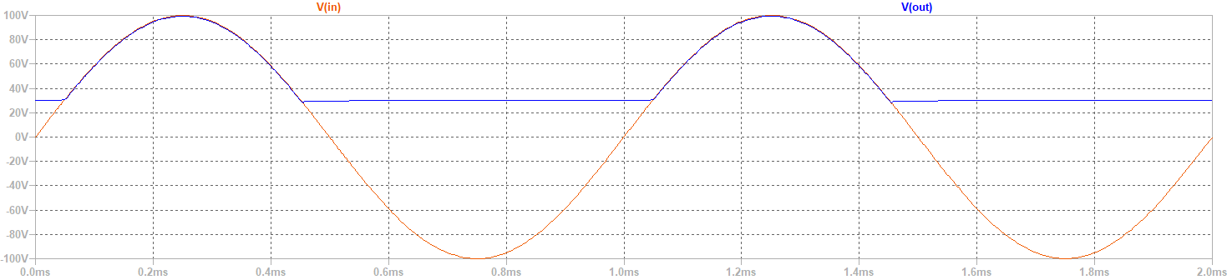

Adjust the DC bias voltage to 200V:

The polarity of the DC bias voltage -200V is reverse bias for the diode (200V>100V), so the input voltage won’t pass through the diode. The output voltage will hence be the DC bias voltage.

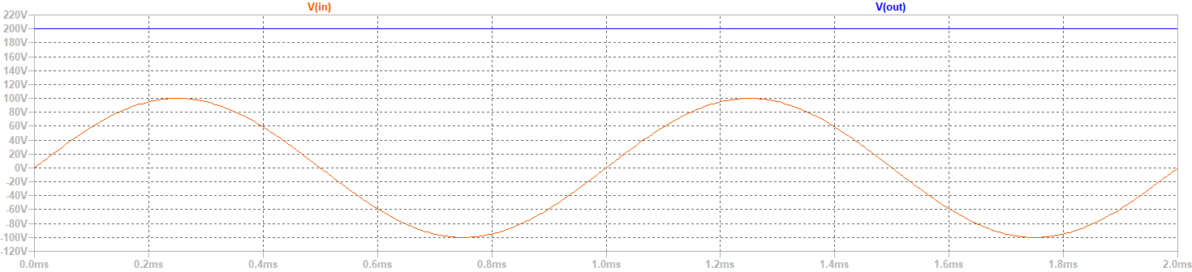

1. Yes, if there is AC voltage passing the clamping circuit, the output waveform will be converted as will.

Given an example of, when the input voltage is below AC voltage, then it will cause reverse bias to the diode. Hence the output voltage will follow the AC voltage passing the clamping circuit.

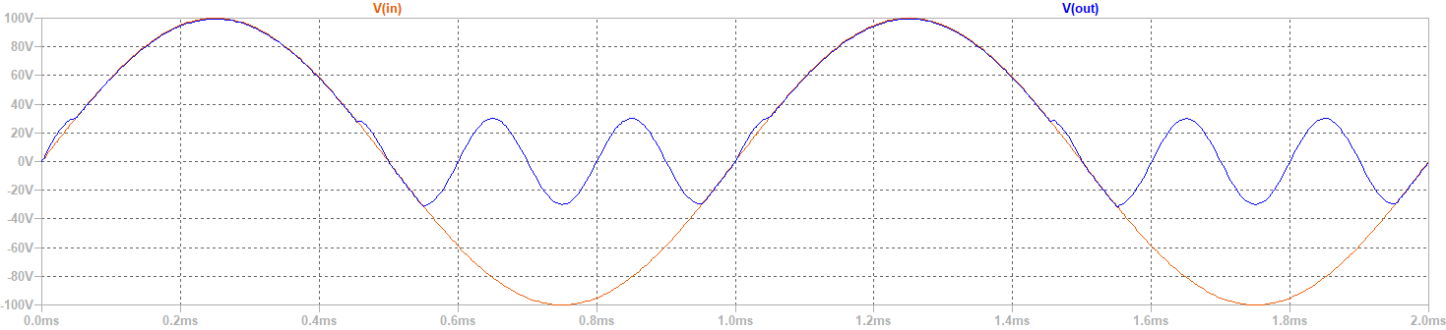

1. Original circuit ($R_{S}≪ R_{L}$):

The output waveform is the lower-half part of the input waveform.

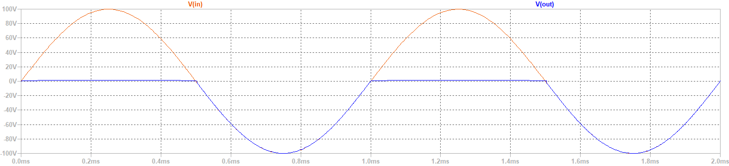

When $R_{S}=R_{L}:$

The output waveform is the lower-half part of the input waveform, while the peak value is 1/2 of the input value.



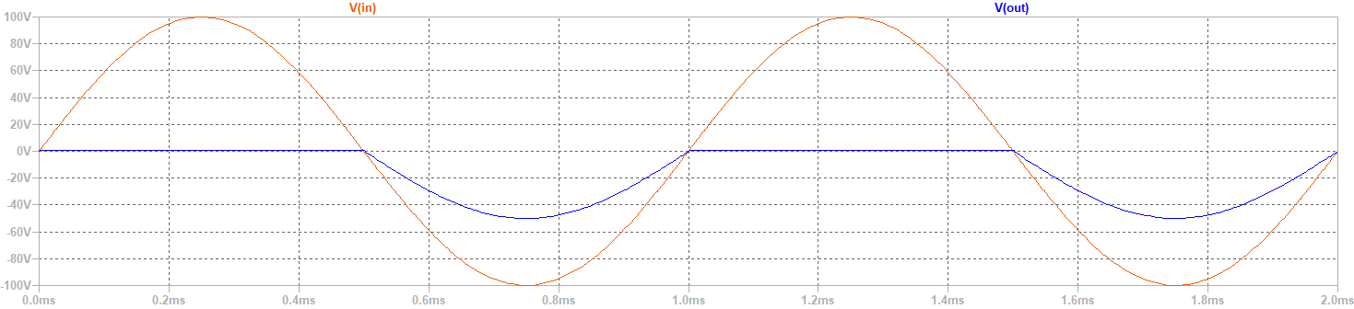

1. Original circuit:

 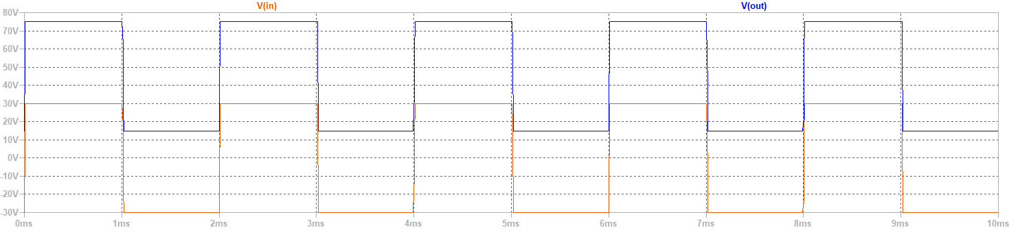

When E=30V:

 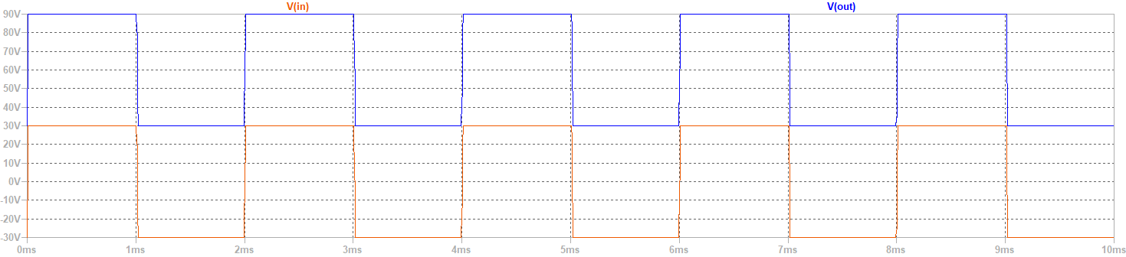

Feedback

In this experiment, we learned about the principles and applications of clipping and clamping circuits. These circuits have a good effect on adjusting the amplitude and offset of the input signal, and can protect the downstream circuits from over-output and damage.

Through this experiment, we not only learned theoretical knowledge but also exercised our practical skills. In the experiment, we needed to carefully adjust the components and parameters in the circuit to achieve the desired effect. We also found that using the circuit simulation software LTspice can make the experiment more convenient and efficient, and help us become more familiar with the tool.

Finally, I would like to thank my teammate for her help and cooperation, which allowed us to successfully complete this experiment. I also believe that the knowledge and skills learned in this experiment will be of great help to our future learning and work.